Session 2026-2027

Vision:Dream of where you want. | Mission: Means to achieve Vision

Program Educational Objectives of the program (PEO): (broad statements that describe the professional and career accomplishments)
PEO1 | Preparation | P: Preparation | Pep-CL abbreviation  pronounce as Pep-si-lL easy to recall
PEO2 | Core Competence | E: Environment (Learning Environment)
PEO3 | Breadth | P: Professionalism
PEO4 | Professionalism | C: Core Competence
PEO5 | Learning Environment | L: Breadth (Learning in diverse areas)

Program Outcomes (PO): (statements that describe what a student should be able to do and know by the end of a program)
Keywords of POs:
Engineering knowledge,Problem analysis, Design/development of solutions,Conduct Investigations of Complex Problems, Engineering Tool Usage, The Engineer and The World,Ethics, Individual and Collaborative Team work,Communication, Project Management and Finance, Life-Long Learning

PSO Keywords: Cutting edge technologies, Research

“I am an engineer, and I know how to apply engineering knowledge to investigate, analyse and design solutions to complex problems using tools for entire world following all ethics in a collaborative way with proper management skills throughout my life.” to contribute to the development of cutting-edge technologies and Research.

Integrity: I will adhere to the Laboratory Code of Conduct and ethics in its entirety.

Name and Signature of Student and Date
(Signature and Date in Handwritten)

Session | 2026-27 (ODD) |  | Course Name | Web Technology Lab
Semester | 3 |  | Course Code | 23CT1301
Roll No | 67 |  | Name of Student | Sumit jadhao
Practical Number |  | 2
Course Outcome |  | - Understand various internet technologies.  - Design the web pages using HTML and CSS.  - Implement the XML technology to store the data.  - Develop the interactive web pages using JavaScript.
Aim |  | Create a web form by using form tags in HTML
Problem Definition |  | To create a student registration form using HTML form elements such as text fields, email, password, radio buttons, dropdown lists, textarea, checkbox, submit, and reset buttons.
Theory  (100 words) |  | HTML forms are used to collect information from users on a web page. A form can contain different input fields such as name, email, password, phone number, date of birth, gender, department, semester, and address. Text boxes are used to enter short information, while textarea is used for longer text. Radio buttons allow the user to select one option, and checkboxes are used for confirmation. Dropdown lists help users choose an option from a list. Submit and reset buttons are used to send or clear the entered information. HTML forms are commonly used for registration and data collection.
Procedure and Execution  (100 Words) |  | Step for Implementation:  - Open a text editor such as VS Code, Notepad, or Sublime Text.  - Create a new file and save it as index.html.  - Write the basic HTML structure using <html>, <head>, and <body> tags.  - Add a heading for the Student Registration Form using the <h2> tag.  - Create the form using the <form> tag.  - Add input fields for name, roll number, email, password, phone number, and date of birth using the <input> tag.  - Add gender options using radio buttons.  - Create department and semester dropdown menus using <select> and <option> tags.  - Add an address field using the <textarea> tag and a confirmation checkbox.  - Add submit and reset buttons, save the file, and open it in a web browser to check the output.
Code:
<!DOCTYPE html>
<html lang="en">

<head>
<meta charset="UTF-8">
<title>Student Registration Form</title>
</head>

<body>

<h2>Student Registration Form</h2>

<form>

Name: <br>
<input type="text" id="name">
<br><br>

Roll Number: <br>
<input type="text" id="roll">
<br><br>

Email: <br>
<input type="email" id="email">
<br><br>

Password: <br>
<input type="password" id="password">
<br><br>

Phone Number: <br>
<input type="text" id="phone">
<br><br>

Date of Birth: <br>
<input type="date" id="dob">
<br><br>

Gender: <br>
<input type="radio" name="gender"> Male
<input type="radio" name="gender"> Female
<br><br>

Department: <br>
<select id="department">
<option>Select Department</option>
<option>CSE</option>
<option>IT</option>
<option>ECE</option>
<option>Mechanical</option>
</select>
<br><br>

Semester: <br>
<select id="semester">
<option>Select Semester</option>
<option>Semester 1</option>
<option>Semester 2</option>
<option>Semester 3</option>
<option>Semester 4</option>
</select>
<br><br>

Address: <br>
<textarea ></textarea>
<br><br>

<input type="checkbox">
I confirm that the above information is correct.
<br><br>

<input type="submit" value="Register">
<input type="reset" value="Reset">

</form>

</body>

</html>
Output:

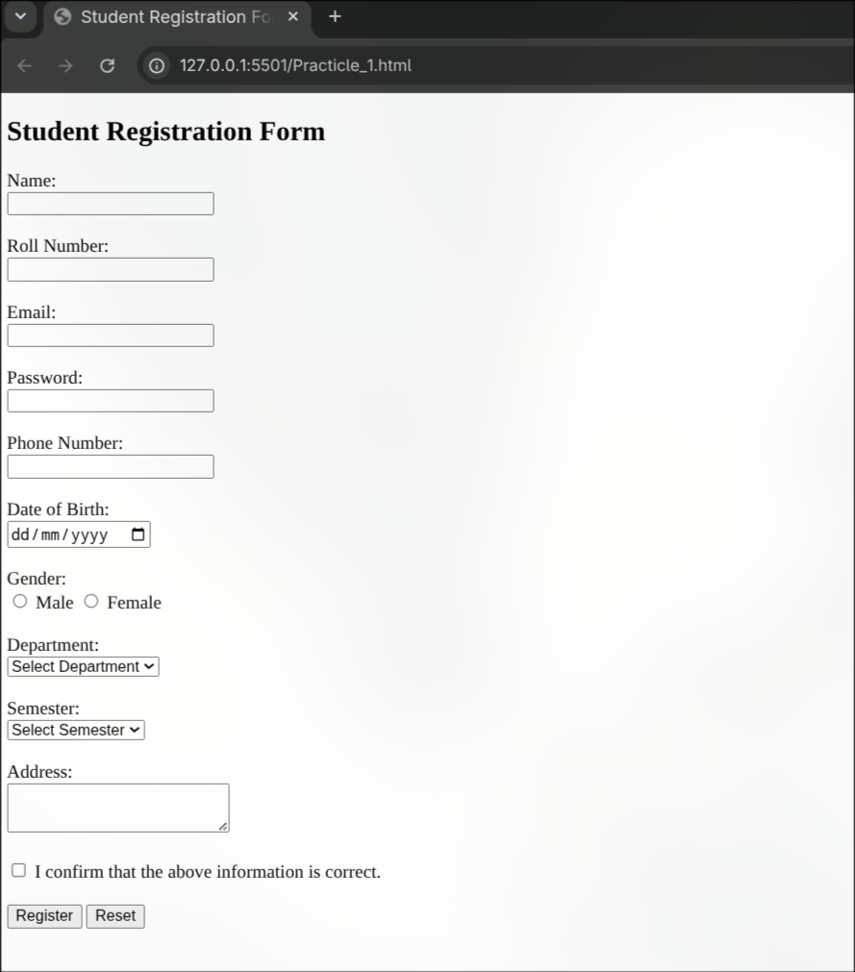

Output Analysis |  | The student registration form was successfully created and displayed in the web browser. It contains input fields for name, roll number, email, password, phone number, and date of birth. Radio buttons are used for gender selection, dropdown lists are used for department and semester, and a textarea is provided for the address. A checkbox is included for confirmation. The Register button is used to submit the form, while the Reset button clears all entered information.
Link of student Github profile where lab assignment has been uploaded |  | https://github.com/Sumit0745
Conclusion |  | In this practical, I learned how to create a student registration form using HTML form tags. I used different input elements such as text fields, radio buttons, dropdown lists, textarea, checkbox, submit, and reset buttons. This practical helped me understand how HTML forms are used to collect information from users on a web page.
Plag Report (Similarity index < 12%)
Date |  | 14/07/2026

